
RAMAIAH
Institute of Technology
USN | 1 | M | S

(Autonomous Institute, Affiliated to VTU)
(Approved by AICTE, New Delhi & Govt. of Karnataka) Accredited by NBA & NAAC with ‘A’ Grade

MAKEUP EXAMINATIONS – JUNE/JULY2018

Course & Branch | : | B.E. : Electrical and Electronics Engg. | Semester | : | VI
Subject | : | Power Systems - I | Max. Marks | : | 100
Subject Code | : | EE61/EE601 | Duration | : | 3 Hrs

Instructions to the Candidates:
- Answer one full question from each unit.

 |  | UNIT- I
1. | a) | Discuss major advantages of per unit system in detail. | CO2 | (06)
 | b) | Show that the pu impedance of a transformer is same whether it is referred to its LV side or HV side. | CO1 | (06)
 | c) | A generator connected through a circuit breaker to a transformer is rated 100MVA, 18kV, with reactances of X_{d}”= 19% and X_{d}= 130%. It is operating on no load and rated voltage when a three phase short circuit occurs between the breaker and the transformer. Find i) The steady state short circuit current in the breaker ii) The initial sub-transient current in the breaker and c) The maximum possible dc component of the short circuit current in the breaker. | CO3 | (08)
2. | a) | Explain the concept of complex power and the direction of power flow. | CO2 | (06)
 | b) | Draw the pu reactance diagram for the power system shown in fig. 2(b). Use a base of 50kVA, 13.8kV in the 40Ω line. The ratings of the generators, motor and transformers are given below. 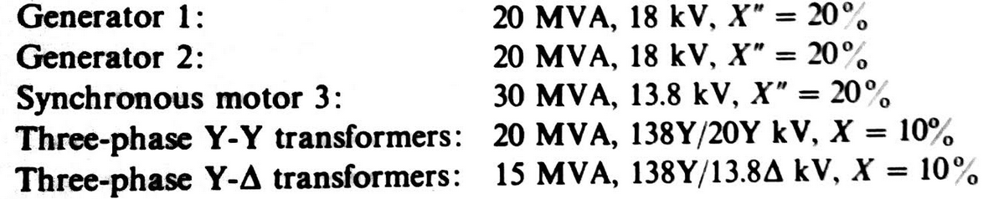  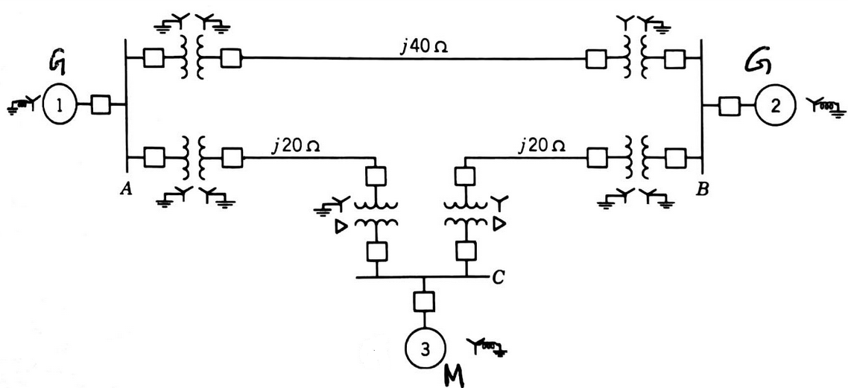  Fig. 2(b) | CO1 | (14)
 |  | UNIT- II
3. | a) | What are symmetrical components? How they are useful in solving power systems problems? | CO4 | (05)
 | b) | A delta connected resistive load is connected across a balanced three phase supply of 400V as shown in Fig 3(b). Find the symmetrical components of line currents and delta currents.  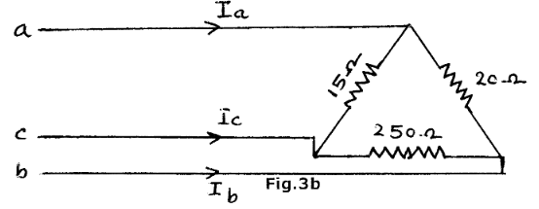 | CO4 | (08)
 | c) | Derive phase currents of unbalance system in terms of sequence currents in delta connected circuits. | CO4 | (07)
4. | a) | Develop an expression for three phase power in terms of symmetrical components. | CO4 | (08)
 | b) | Three identical Y-connected resistors from a load bank with a three phase rating of 400V, 100kVA. Unbalanced voltages are applied to the load bank as follows:|V_{ab}|=320V; |V_{bc}|=480V; |V_{ca}|=400V. The neutral of the load is not connected to the neutral of the system. On a base of 400V, 100kVA, find the line voltages and currents into the load in per unit. | CO4 | (12)
 |  | UNIT- III
5. | a) | A star connected synchronous generator has sequence reactances X₀=0.09, X₁=0.22, X₂=0.36 all in pu. The neutral point of the machine is grounded through a reactance of 0.09 pu. The machine is running on no load with rated terminal voltage when it suffers an unbalanced fault. The fault currents out of the machine are I_{a}=0, I_{b}=3.75∟150⁰, and I_{c}=3.75∟30⁰, all in pu with respect to phase ‘a’ line to neutral voltage. Determine i) the terminal voltages in each phase of the machine with respect to ground ii) the voltage of the neutral point of the machine with respect to ground and iii) the fault type . | CO4 | (10)
 | b) | Explain the sequence networks of:  i) unloaded generators ii) transmission lines. | CO4 | (10)
6. | a) | Determine the negative and zero sequence networks for the system shown in Fig.6(a). Assume zero sequence reactance for the generator and synchronous motors as 0.06pu. Current limiting reactors of 2.5Ω are connected in the neutral of the generator and motor M₂. The zero sequence reactance of the transmission line is j300 Ω.  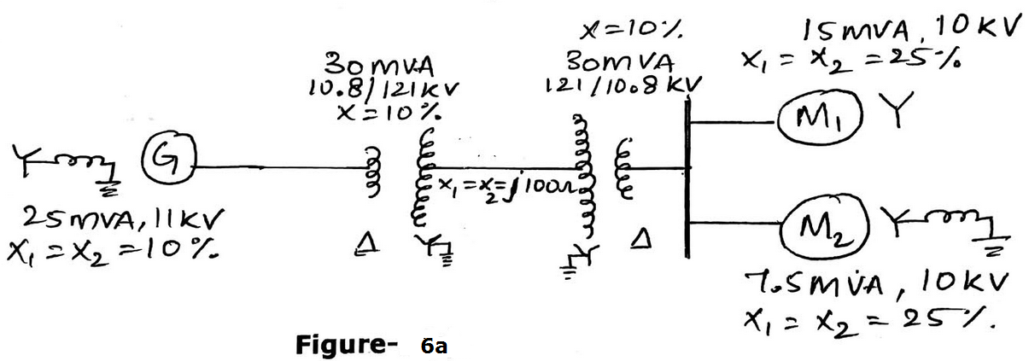 | CO4 | (10)
 | b) | Obtain the sequence networks of an unloaded three phase star connected generator grounded through a reactor. | CO4 | (10)
 |  | UNIT- IV
7. | a) | Derive an expression for fault current for double line to ground fault through impedance by symmetrical components method. | CO4 | (10)
 | b) | A three phase, 11kV, 10MVA alternator has sequence reactance of X₀=0.05pu, X₁=0.15pu, X₂=0.15pu. If the generator is on no load, find the ratio of fault currents for LG fault to that when all the three phases are short circuited. | CO4 | (10)
8. | a) | Explain in detail, single line to ground fault that occurs on an unbalanced generator. | CO4 | (10)
 | b) | A three phase generator with line to line voltages of 400V is subjected to an LLG fault. If Z₁=j2Ω, Z₂=j0.5Ω, and Z₀=j0.25Ω. Determine the fault current terminal voltages. | CO4 | (10)
 |  | UNIT- V
9. | a) | Explain the power angle equation. The single line diagram shown in fig.9(a) shows a generator connected through parallel transmission lines to a large metropolitan system considered as an infinite bus. The machine is delivering 1pu power and both the terminal voltage and the infinite bus voltage are 1 pu. Numbers on the diagram indicate the values of reactances on a common system base. The transient reactance of the generator is 0.2puas indicated. Determine the power angle equation for the system applicable to the operating conditions.  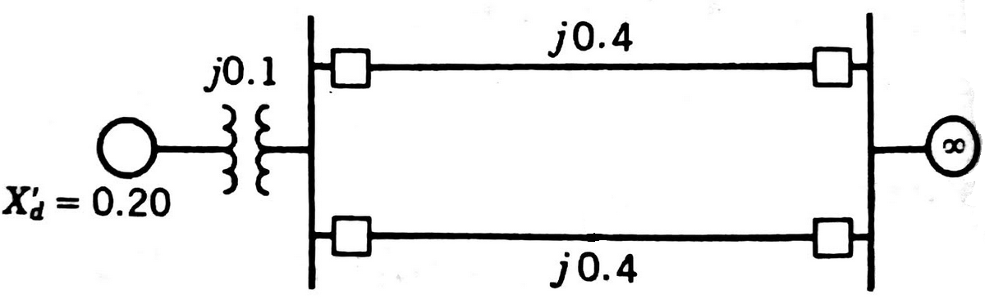  Fig.9(a) | CO5 | (14)
 | b) | Explain the factors affecting the transient stability. | CO5 | (06)
10. | a) | A 60-Hz generator is supplying 60% of P_{max} to an infinite bus through a reactive network. A fault occurs which increases the reactance of the network between the generator terminal voltage and the infinite bus by 400%. When the fault is cleared the maximum power that can be delivered is 80% of the original maximum value. Determine the critical clearing angle for the condition described. | CO5 | (08)
 | b) | Explain equal area criterion and its significance in fault analysis. | CO5 | (12)

****************

